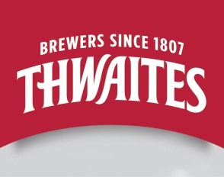
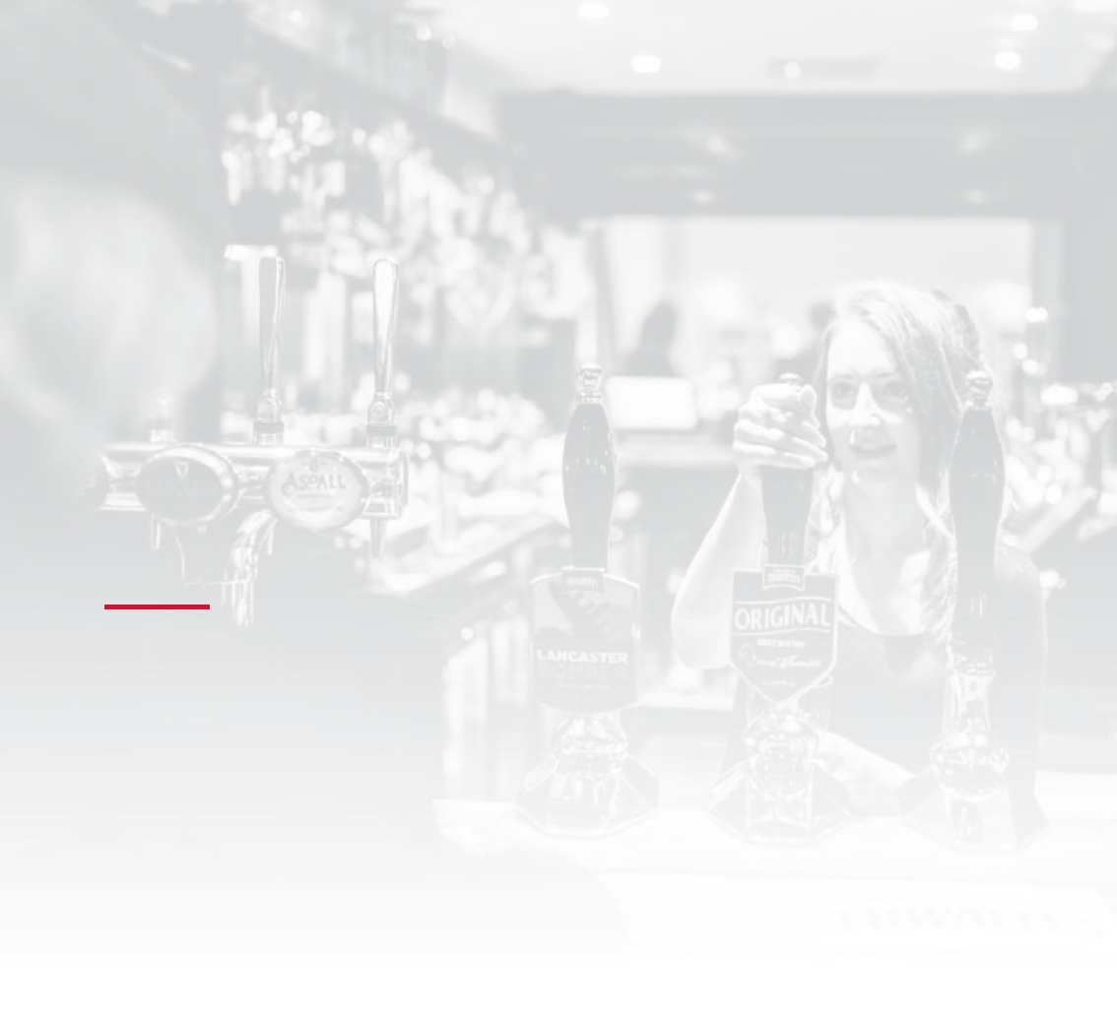

BUSINESS PLAN
“Failing to plan is planning to fail”

Pub Name:
Submitted By:

The content of your business plan could determine whether you are offered a tenancy opportunity. Please take time and effort to complete all sections thoroughly and add any supporting documents.

YOUR EXPERIENCE
Give a brief account of your industry experience including bar work, managerial roles, catering/kitchen and/or experience of running a business

THE CURRENT BUSINESS
What times of the day have you visited the pub?
Please give a brief description of your overall impressions of the business
Detail your knowledge of the local area, investment, out of home leisure choices, schools, universities etc
Describe the local demographics and who lives in the area
What type of people currently use the pub? Think about their occupations, housing, cultures

TARGET MARKET
Describe the types of customers that you would like to attract into the pub Would you build on the existing customers or change the type of clientele?
Are there any specific changes you could implement to make the pub appeal to other customers?

COMPETITION ANALYSIS
Look at competition in the area.
Do not restrict this to pubs, think about other business For example, restaurants, coffee shops, cafes etc.
Please detail a minimum of 3 competitors. Give information of the name and type of business, the average cost of a menu main course and the cost of a pint of standard lager/cask ale

Business:
Main course £ | Lager £ | Cask Ale £
Business:
Main course £ | Lager £ | Cask Ale £
Business:
Main course £ | Lager £ | Cask Ale £
Business:
Main course £ | Lager £ | Cask Ale £

How would you attract your target market from the competition?
How would you improve on their offer to make your pub the preferred choice?

MYSTERY CUSTOMER
ACTING AS A MYSTERY CUSTOMER,
VISIT THE PUB AND COMMENT ON THE FOLLOWING...
KERB APPEAL
How is the pub presented from the outside? What was your first impression?
INTERIOR
Give your thoughts on the appearance and atmosphere inside the pub
STAFF AND SERVICE
How was the service you received?
BAR
Is there a good product range?
FOOD (IF APPLICABLE)
Give your thoughts on the current menu
MARKETING
Are promotions advertised via A-boards, posters etc?
Does the pub have a website or use social media channels? Please comment below
LASTING IMPRESSIONS?

INDUSTRY TRENDS
PUBS IN THE CURRENT DAY AND THE FUTURE...
We all know that times are changing for pub businesses. Pubs need to be relevant to the times and appealing to the consumer. Please consider the key trends below and describe how you would react to these changes, and when possible, use them to the advantage of your business
Less consumption of alcohol - Pubs cannot rely on alcohol only
People are more health conscious
Continual rising expectations of quality and value for money
People are living longer, with the 45-65 age group the most wealthy
Mixed cultures and ethnicities
Deregulation of traditional eating / meal times (not strictly breakfast-lunch-dinner)
New technology wifi , mobile payments, smart technology
People look for novelty, new experiences to complement tradition
Customers seek non-healthy choices on certain occasions

INDUSTRY TRENDS
Specifically describe how you will attract customers. Please consider: 1 Opening hours
2 Bar products and pricing 3 Food offer and pricing
4 Staff and training 5 Entertainment
- Letting rooms (if applicable)
- Marketing (print, digital including social media)
Consider timescales and what you would achieve in 3, 6 and 12 months
1
2
3
4
5
6
7

ADDITIONAL INFORMATION
Please add any supporting documents for your business plan such as:
- Sample menus
- Examples from previous/other pubs - awards, recognition, press exposure, ratings
- Association with professional bodies - BII, Cask Marque etc.
- Association with community groups relevant to the pub/area

TWELVE MONTH PROFIT AND LOSS FORECAST
Using the rent Profit and Loss calculation provided, complete the template using your own estimations. Take into consideration other costs such as those associated with fixtures and fittings and personal outgoings. Does the anticipated profit match your personal income expectations?

Please note that the guide rent for the pub will not change regardless of your forecast. You may wish to employ the services of an Accountant to assist with this exercise.

SALES OPERATING COSTS
Drink Sales:
Food Sales:
Machine Takings:
Accommodation:
Other (specify):
TOTAL SALES:

Rent:
Business Rates:
Wages (inc. NI):
Utilities (Electric, Gas, Water):
Music, Entertainment and Promotions:
Satellite TV:
Rental Equiptment:
Advertising and Entertainment:
Cleaning Materials:
Glassware and Crockery:
Flowers and Garden:
Telephone and Postage:
Travel and Transport:
Repairs and Decorations:
Insurance:
Stocktaking Fees:
LegalFees and Licensing:
Accountacy Fees:
Bank Charges:
Loan Repayments:
Other Costs (specify):
TOTAL COSTS (1):

PURCHASES
Drink Purchases:
Food Purchases:
Other (specify):
TOTAL PURCHASES:

GROSS PROFIT % GP% = Total GP (£’s) divided by total
sales multiplied by 100.

Drink: | Wet GP%:
Food: | Dry GP%:
Machine Takings:
Accomodation:
Other (specify):
TotalGP($’s): | Overall GP% (2):
DRAWINGS:
NET PROFIT (before drawings):

e drawings)
WEEKLY BREAK EVEN SALES CALCULATION
1 Total cost ﬁgure / total operating costs 2 Overall GP% from above
3 Divide (1) by (2) and multiply by 100 4 Add VAT by multiplying by 1.2
5 Divide by 52 to give weekly break even point
Weekly Break Even = £

SOURCE OF FUNDS
Cash Secured Loan

Unsecured Loan

Overdraft

Other (specify) TOTAL

SIGNING OFF YOUR PLAN

Pub Name: Signature:

